GRANARD MUNICIPAL DISTRICT

Corporate Affairs,
Aras an Chontae,
LONGFOIRT.

16th February 2016.

To: Each Member of Granard Municipal District.

Dear Member,

You are requested to attend Meeting of Granard Municipal District to be held in
Granard Community Library on Tuesday, 23rd February 2016 at 3.00 p.m. to transact business, as set out on the Agenda hereunder.

Yours sincerely,
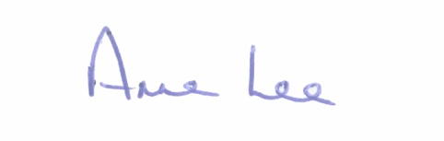

_______________
Anne Lee,
Meetings Administrator.

AGENDA

Prayer before meeting.

- Consideration of 2016 – 2018 Multi-Annual Restoration Improvement Programme – report enclosed.

- Consideration of Schedule of Granard Municipal District Works -
report enclosed.

::::::::::::::::::::::::::::::::::

